Spheres
Multiple Choice
- Recall what the biosphere contains.
- All of the planet's water
- The ozone layer
- All of the planet's living organisms
- The Earth's crust and soils

- State the components of the hydrosphere.
- The earth’s oceans and rivers
- The earth’s icebergs
- The earth’s rainfall.
- All of the above.

- State the components of the atmosphere.
- All the gases above Earth’s surface.
- Clouds, rain and gases
- All the living things on Earth.
- All the water on Earth’s surface.

- Recall which of the following options are not part of the lithosphere.
- Soil
- Grass
- Mountains
- Rocks

- The Earth is comprised of four spheres: the atmosphere, the lithosphere, the biosphere and the hydrosphere.
This picture contains the sea and seaweed. Identify the two spheres that these things are present in.
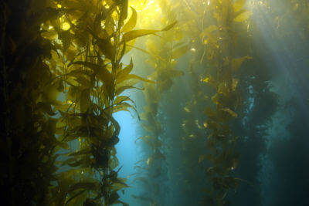

- Hydrosphere and biosphere
- Hydrosphere and lithosphere
- Atmosphere and lithosphere
- Atmosphere and hydrosphere

- The Earth is comprised of four spheres: the atmosphere, the lithosphere, the biosphere and the hydrosphere.
This picture contains the sea and the sky. Identify the two spheres that these things are present in.
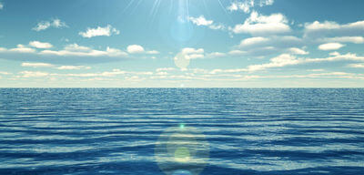

- Atmosphere and biosphere
- Atmosphere and lithosphere
- Atmosphere and hydrosphere
- Hydrosphere and biosphere

- The Earth is comprised of four spheres: the atmosphere, the lithosphere, the biosphere and the hydrosphere.
This picture contains an animal and dirt. Identify the two spheres that these things are present in.
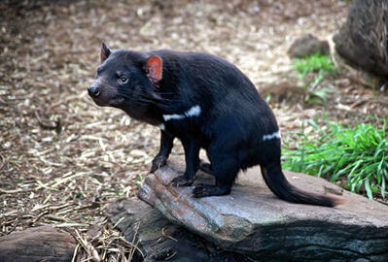

- Biosphere and lithosphere
- Biosphere and atmosphere
- Lithosphere and atmosphere
- Atmosphere and hydrosphere

- Specify the two atmospheric layers that the ozone layer sits between.
- Thermosphere and mesosphere
- Stratosphere and troposphere
- Stratosphere and thermosphere
- Stratosphere and mesosphere

- State the components of the ozone molecule.
- One oxygen atom and two hydrogen atoms
- Three oxygen atoms
- Two oxygen atoms
- Two oxygen atoms and one nitrogen atom

- Recall the physical state of ozone.
- A solid
- A layer of clouds
- A liquid
- Gas

- Describe the impact of pollutants on the ozone layer.
- Degraded it so it disappeared completely
- Caused it to move further away.
- Made it thicker
- Degraded it and formed a hole.

- Ozone is a very reactive gas.
Recall which of the following reacts with ozone.
- Bromine
- Chlorine
- Hydrogen
- All of the above
Fill in the blanks
- Use the following words to fill in the gaps.
lithosphere, glaciers, hydrosphere, water, rocks

The Earth’s ________________ is made up of all the ______________ on our planet. This includes all of the salt water oceans, fresh water lakes, _______________ and underground deposits.

The ______________ includes all ________________ and geological structures on which life exists such as soil rocks and mountains.

- Use the following words to fill in the gaps.
stratosphere, reducing, earth’s surface, absorb

The role of the ____________ is to _____________ the UVB radiation from the sun ____________ the amount of UVB radiation making contact with the ____________.

- Use the following words to fill in the gaps.
atmosphere, biosphere, stable, gases, weather, sun, unstable

The _____________ contains all the _____________ above Earth. Parts of the atmosphere contain the _____________ and greenhouse gases that keep Earth’s temperatures _____________.

